**NASA or SpaceX website**

**(Project Exam1)**

**Assignment**

**(Report)**

**Prepared by:**

**Raja waqas ahmed**

1. **Introduction:**

This report represents the decisions made for the choices regarding SpaceX website prototype/wireframe, storyboards. The process started by analyzing and understanding the users first, and creating the main categories of information and its flow. After that, the different design choices were checked and then finally developed and tested the website with the chosen design and information.

1. **Analyze the users:**

Considering different types of website audience (adults, children and seniors), we have tried to gather and analyze information. Mostly the target audience for this website are Adults, but most focus is on age range from 30 to above (young, tech-savvy or both).

To understand the users goal and intention, I have designed a questionnaire that I sent to different people. The questionnaire is represented as follows:

|  |
| --- |
| **Questionnaire regarding Leather Shoe Company:**  Dear,  This is my project assignment to create a website for NASA or SpaceX. In this context, I have to do research, analysis, design and development about space micro-website.  Kindly answer these question as a USER of a Space website.   1. What is your primary Goal to visit the website? 2. What other information would you like to get from this website? 3. What kind of content you would like to have on Space Website? 4. Would you like to use the website for purchasing the product related to space or NASA? 5. Are you interested in the Live streaming of Launching event and Space? 6. Are you interested the Pictures and Videos about Space, Planets, Stars and Galaxy? 7. Would you like to get information about Space technology in terms of books, DVDs, Seminars and webinars? |

Following feedback is received from persons:

**Person 1:**

QNo1: What is your primary Goal to visit the website?

Ans: To get information of projects and see pictures.

Qno2: What other information would you like to get from this website?

Ans: Interactive material to learn more about the space.

Qno2: What kind of content you would like to have on Space Website?

Ans: Diverse and informative

Qno4: Would you like to use the website for purchasing the product related to space or NASA?

Ans: Sure

Qno5: Are you interested in the Live streaming of Launching event and Space?

Ans: Off-course

Qno6: Are you interested the Pictures and Videos about Space, Planets, Stars and Galaxy?

Ans: Yes

Qno7: Would you like to get information about Space technology in terms of books, DVDs, Seminars and webinars?

Ans: Yes

**Person 2:**

QNo1: What is your primary Goal to visit the website?

Ans: At this type of site I came to check pictures about space or videos about space.

Qno2: What other information would you like to get from this website?

Ans: Interactive material to learn more about the space.

Qno2: What kind of content you would like to have on Space Website?

Ans: Diverse and informative

Qno4: Would you like to use the website for purchasing the product related to space or NASA?

Ans: no.

Qno5: Are you interested in the Live streaming of Launching event and Space?

Ans: yes if it seems interested

Qno6: Are you interested the Pictures and Videos about Space, Planets, Stars and Galaxy?

Ans: Yes

Qno7: Would you like to get information about Space technology in terms of books, DVDs, Seminars and webinars?

Ans: Yes

**Person 3:**

QNo1: What is your primary Goal to visit the website?

Ans: Check news about space or if there is any seminar /expo.

Qno2: What other information would you like to get from this website?

Ans: About space or Nasa.

Qno2: What kind of content you would like to have on Space Website?

Ans: live news feeds.

Qno4: Would you like to use the website for purchasing the product related to space or NASA?

Ans: no.

Qno5: Are you interested in the Live streaming of Launching event and Space?

Ans: yes if it seems interested.

Qno6: Are you interested the Pictures and Videos about Space, Planets, Stars and Galaxy?

Ans: Yes

Qno7: Would you like to get information about Space technology in terms of books, DVDs, Seminars and webinars?

Ans: Yes

**Person 4:**

QNo1: What is your primary Goal to visit the website?

Ans: Open to show my Kids to take intrest in space related information or NASA information.

Qno2: What other information would you like to get from this website?

Ans: Program for kids or any other related information about kids.

Qno2: What kind of content you would like to have on Space Website?

Ans: Reading Materials or Kids related Stuff.

Qno4: Would you like to use the website for purchasing the product related to space or NASA?

Ans: if something special for kids toys or books.

Qno5: Are you interested in the Live streaming of Launching event and Space?

Ans: yes if it seems interested.

Qno6: Are you interested the Pictures and Videos about Space, Planets, Stars and Galaxy?

Ans: Yes

Qno7: Would you like to get information about Space technology in terms of books, DVDs, Seminars and webinars?

Ans: Yes

After receiving the feedback of questionnaire, I made following personas:

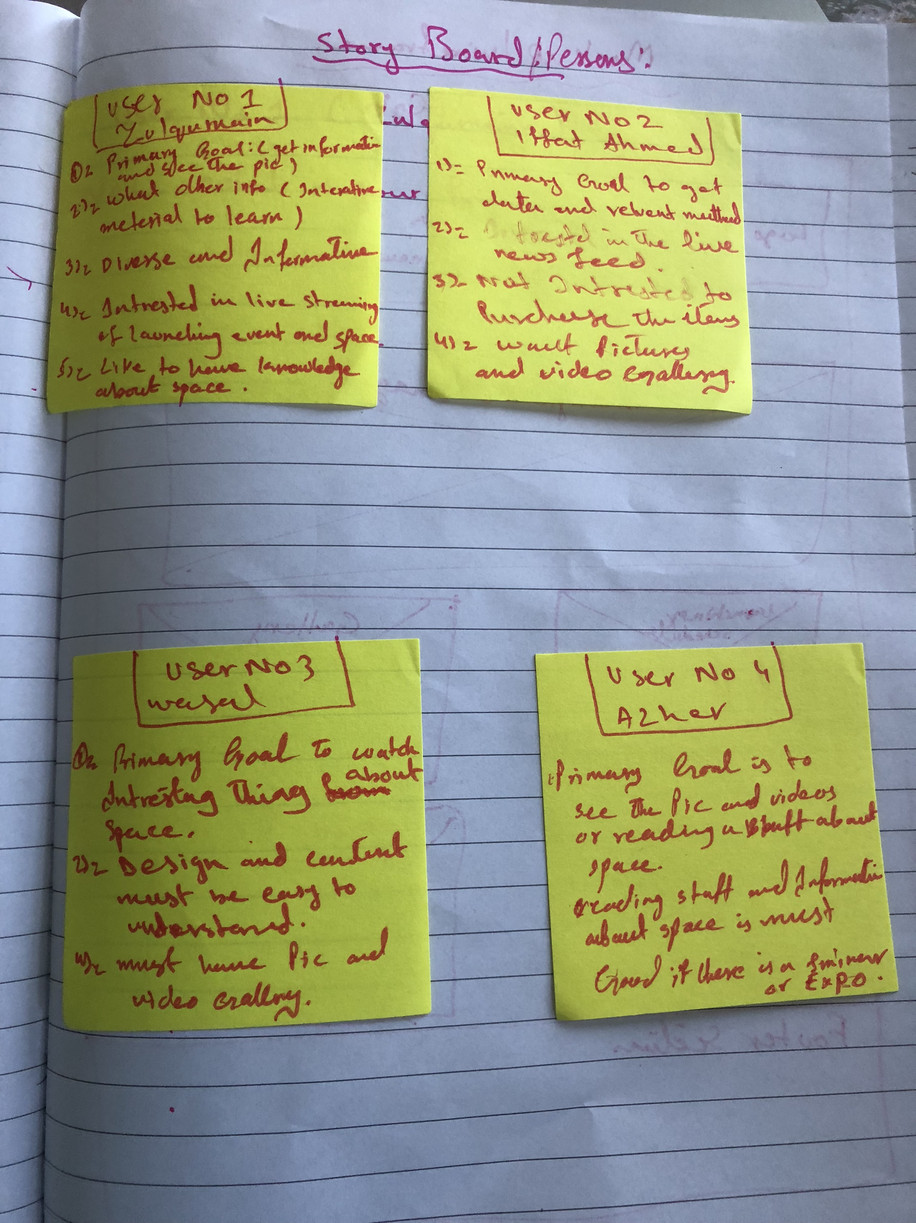

**Wireframes / Sketches of Site:**

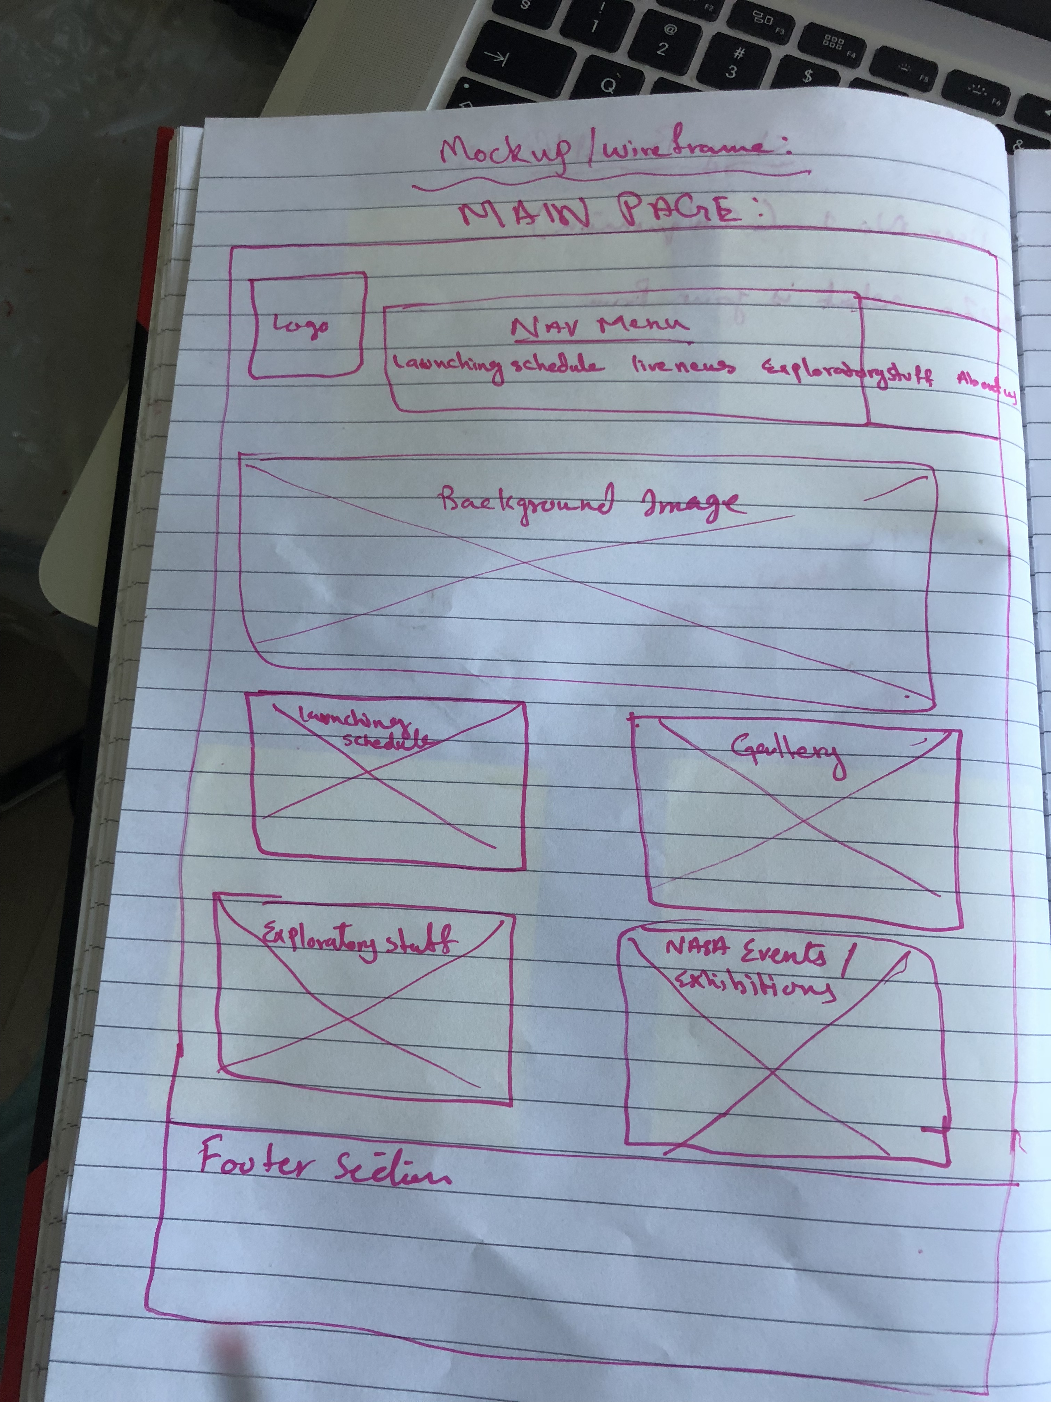

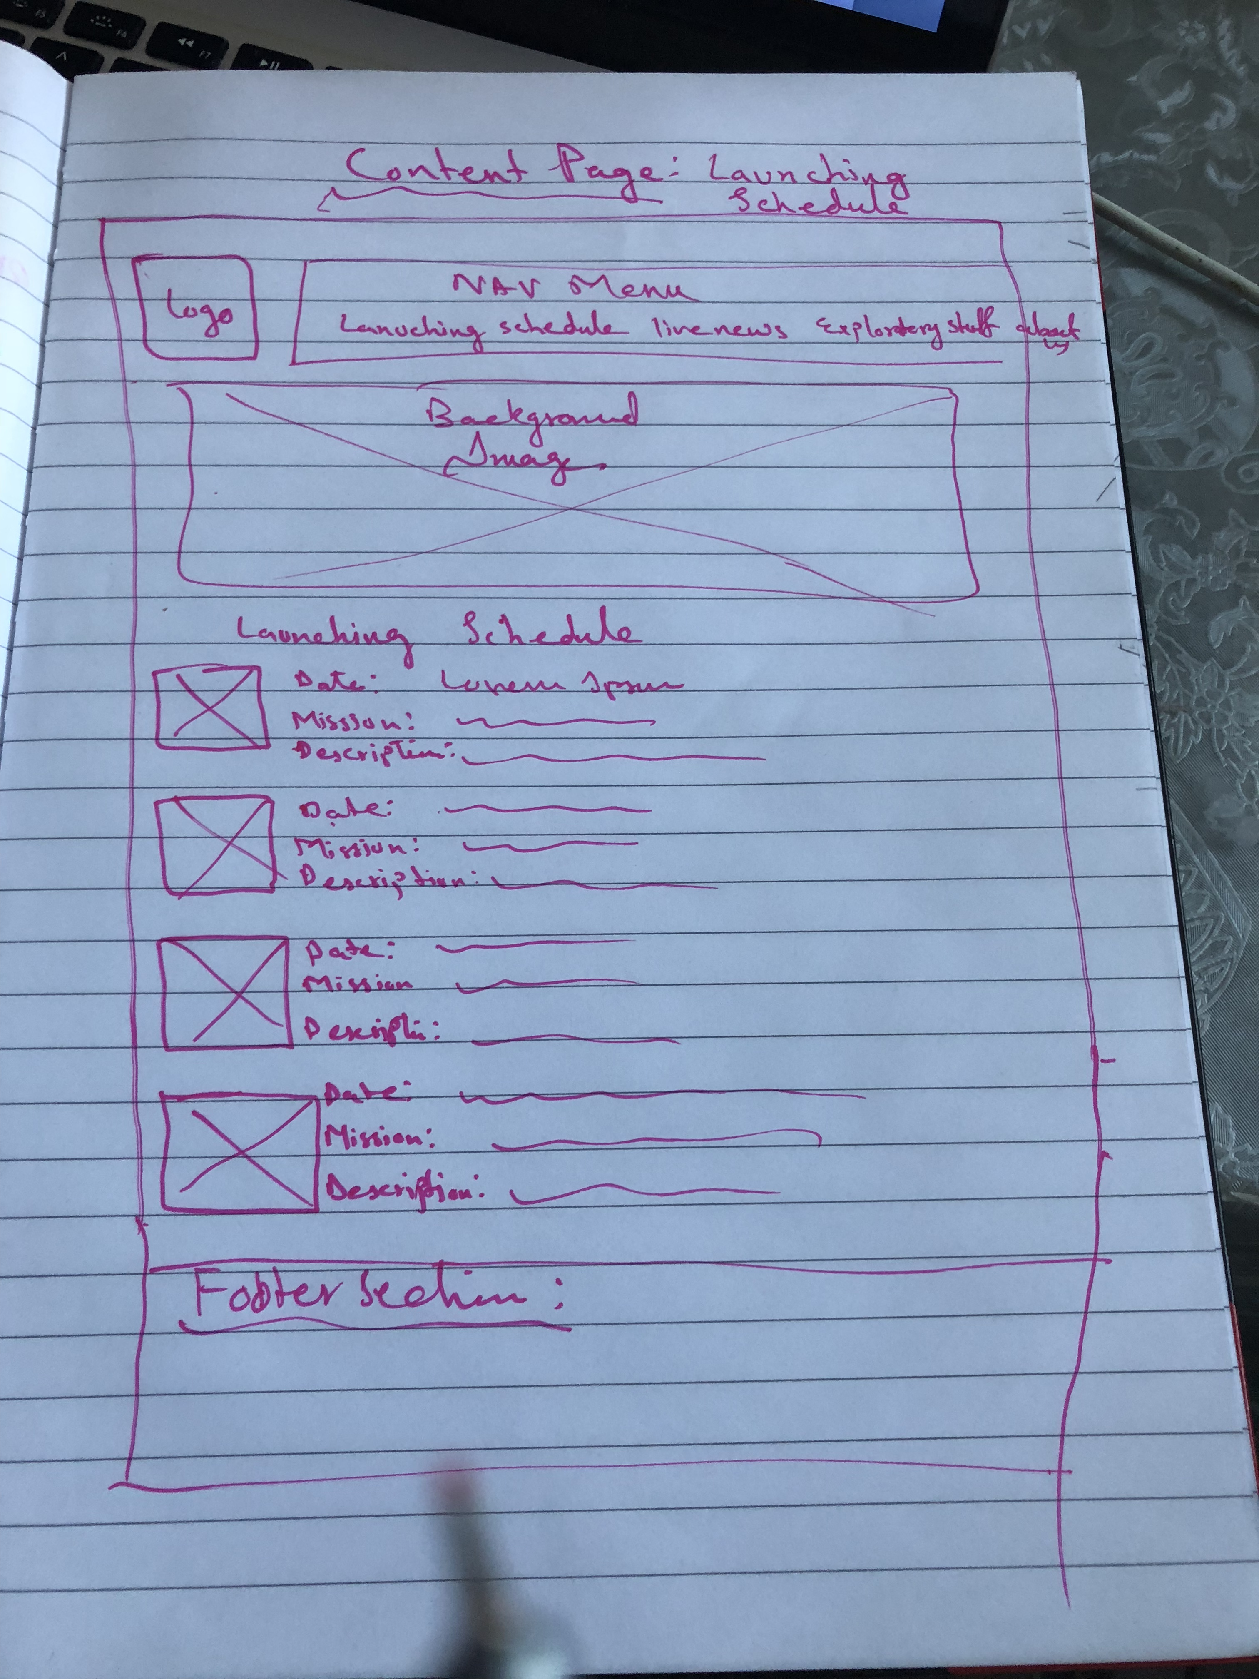

Based on the wireframe designed, I designed and made a prototype in Adobe XD. Following red-colored hierarchy shows the working pages of category and content pages.

* **Home page (LOGO)**
* **Launching Schedule**
* **Gallery**
* **Exploratory Stuff**

1. **URL:**

Here is the URL of Adobe XD prototype:

https://xd.adobe.com/view/7503b5a6-a3f6-4a9e-48cd-e26cee33c1bf-0332/

1. **References:**

[1] Pictures used in design (<https://stock.adobe.com/fi/search?load_type=search&k=library&native_visual_search=&similar_content_id>=)